
QUEUE Design
Design Documentation

Version 1.0
July 2024
Table of Contents

Design Overview 2
Functional Description 3
Size Control 3
Peak operation 3
The value on req_out is assigned to the FIRST IN request in the queue which means the oldest request. 3
Push operation 3
Pull operation 3
Outputs Signals 3
Signal description 4
Queue block 4

List of Figures
Figure 1 : block diagram of the queue design 2

List of Tables
Table 1 Queue block signals 4

Design Overview
The queue block is a queue with maximum physical size of $2^{QUEUE_SIZE}$, where QUEUE_SIZE is a parameterized value, and a programmable maximum value called almost full.

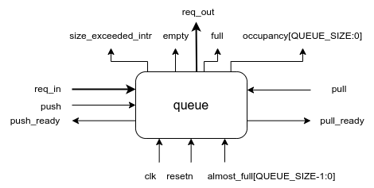
Figure 1: block diagram of the queue design

Functional Description

Size Control
The size can be controlled using almost_full value. Where the queue limits pushing values according to the almost full. The value of almost_full is inverted using 2’s compliment meaning that if almost_full = zero then the size will be $2^{QUEUE_SIZE}$ which is the maximum size, and if almost_full = $2^{QUEUE_SIZE}−1$ then the size will be 1 which is minimum size.

Peak operation

The value on req_out is assigned to the FIRST IN request in the queue which means the oldest request.

Push operation
Push operation is done by asserting the push signal and writing the value to the req input then when the push_ready is asserted the value is pushed to the queue.

Pull operation
Pull operation is done by asserting the pull signal then when the pull_ready is asserted the FIRST IN is pulled from the queue.

Outputs Signals
The outputs signal represent the current state of the queue block. full is 1 if the size of the queue reached or exceeded the limit determined by almost_full. empty is 1 if there is no requests in the queue. size represents the current number of requests in the queue. size_exceeded_intr is asserted when there is push while the maximum size of the hardware is reached, the size_exceeded_intr stay asserted until resetting. push_ready allows push if and only if the size is less than the limit determined by almost_full. pull_ready allows pull if and only if there is at least 1 request in the queue.

Signal description
The main signals:
clock - oscillating between high and low state and synchronizing actions in the circuit.
reset - which sets all the values to a predetermined state.

Queue block
Port Name | Size | I/O | Description
req_in | 1 request | I | Request input.
req_out | 1 request | O | Request output from the queue.
pull | 1 | I | Pull signal used in pull operation.
pull_ready | 1 | O | Pull ready signal used in pull operation.
push | 1 | I | Push signal used in push operation.
push_ready | 1 | O | Push ready signal used in push operation.
full | 1 | O | Full status output.
empty | 1 | O | empty status output.
occupancy | QUEUE_SIZE+1 | O | occupancy status output.
almost_full | QUEUE_SIZE | I | Almost full input.
size_exceeded_intr | 1 | O | Size exceeded interrupt.
Table 1 Queue block signals

